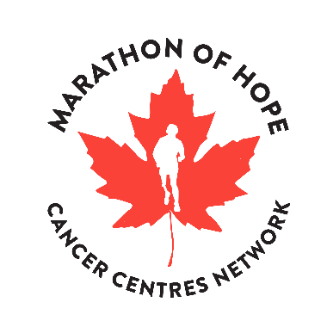
MARATHON OF HOPE CANCER CENTRES NETWORK
SCIENTIFIC PROGRESS REPORT – OTHER PROJECT

Scientific progress reports provide information to the Terry Fox Research Institute about the developments and achievements of research teams and feed into reports to Health Canada. “Other projects” are those that are not generating cases for inclusion in the Gold Cohort and should use this template to report their progress.

Project Number & Title: #### - Title
Period Covered (select one and complete years):
☐ April 1, 20XX to September 30, 20XX
☐ October 1, 20XX to March 31, 20XX
Report Submitted By: Name, Email Address

Highlights
Using bullet points, itemize major achievements during the reporting period. Include updates on work supported by strengthened infrastructure and the development of governance structures.

- Insert text here.

Project Goals, Objectives & Milestones
Explain the progress made towards the deliverables set in your Research Project Grant Agreement (RPGA).

 | Activity | Deliverable/Outcome | Ongoing (Y/N)
1
2

- Insert text here regarding progress of Activity 1.
- Insert text here regarding progress of Activity 2.

Future Work Plan
For six-month report: Comment on the plan in place to complete your project targets by end of fiscal year. Include any alterations to work plan goals and milestones.
For fiscal year-end report: Itemize strategies, plans, arrangements, and funding for follow-on research, development and implementation of the project’s outcomes.

Insert text here.

Project Management
Report on important issues, policies or strategies discussed, and the outcomes, where available.

Insert text here.

Precision Oncology Impact
MOHCCN’s mission is to innovate and implement the world’s most advanced and effective precision medicine for cancer network – treating Canadians across the nation with a Canadian science and technology solution. To relate back to the mission, the following section seeks your input on the impact of this project’s work on precision oncology.
If you answered these questions in a previous report, you can leave them blank or add updates based on work performed during this reporting period.

- Please comment on the gaps, needs and trends in precision cancer medicine that are/will be addressed with knowledge products developed through the project.
Insert text here.

- How will this research project influence future research, particularly in the area of precision cancer medicine?
Insert text here.

- Describe any advances in health promotion, clinical guidelines, health care practices and policies, and delivery of health care services stemming (or that are anticipated to stem) from this research project.
Insert text here.

Submission Date: 6-month: October 31, 20XX / Year-End: April 30, 20XX
Please replace “Template” in the file names with the project number.
Submit To: mohreporting@tfri.ca
Appendix 1: Certificates and Co-Funding
Confirm the status of any project-related certificates required by Host Institutions by checking the applicable boxes below. A copy of the certificates may be required upon audit.

- Have research ethics certificates been renewed?
☐ Yes / ☐ No / ☐ Not applicable

- Have environmental, biohazard, and/or radioactive hazard certificates been renewed?
☐ Yes / ☐ No / ☐ Not applicable

- Have regulatory approvals and amendments for Human Clinical Trial been received?
☐ Yes / ☐ No / ☐ Not applicable

- Are there any changes to co-funding? If yes, please attach related documentation.
☐ Yes / ☐ No / ☐ Not applicable

Additional Information:
Provide additional context for any material changes to Institutional approvals.

Appendix 2: Project Metrics
Please also complete and submit the MOHCCN Project Metrics Report Template found on the website at:
https://www.marathonofhopecancercentres.ca/researcher-hub/administrative-templates-and-guidelines

